**Tasks:**

1**. Select Your Operating System (OS).**

Step 1: Choose an operating system that best suits your preferences and project requirements.

* Visit [Windows 11 Download](https://www.microsoft.com/software-download/windows11" \t "_new).
* Download and Install Windows 11.
* Follow the instructions to download and install the OS.

**2. Install a Text Editor or Integrated Development Environment (IDE)**

Step 1: Select and install a text editor or IDE suitable for your programming languages and workflow.

* Visit [Visual Studio Code Download](https://code.visualstudio.com/Download" \t "_new).
* Download and Install Visual Studio Code.
* Run the installer and follow the setup instructions.

3. **Set up Version Control System**

Step 1: Visit [Git Download](https://git-scm.com/downloads" \t "_new).

* Install Git and configure it on your local machine.
* Run the installer and follow the setup instructions.

Step 2: Visit [GitHub](https://github.com" \t "_new) and sign up.

* Create a GitHub account for hosting your repositories.

Step 3: Initialize a Git repository for your project and make your first commit.

* Open VS Code.
* Open the terminal
* Run the following commands:
  + - * Git Bash
      * Git init
      * Git add .
      * Git commit -m "My first commit”

**4. Install Necessary Programming Languages and Runtimes**

Step 1: Install Python required for your project.

* + - Visit [Python Download](https://www.python.org/downloads/" \t "_new).

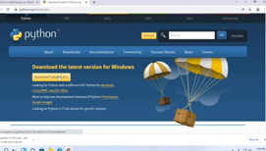

* + - Download and run the installer. Ensure you check the box to add Python to your PATH.

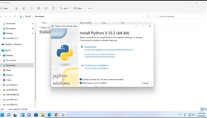

Step 2: Verify the installation by running:

* Run the following commands:
  + - * + Git bash
        + Python –version

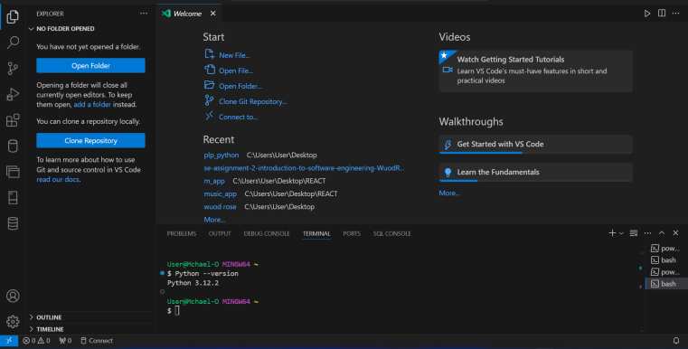

**5. Install Package Managers**

Step 1: Install package managers like pip for Python.

* Pip is included with Python installation. Verify by running:
* Run the following commands:
  + - * + Git bash
        + Pip –version

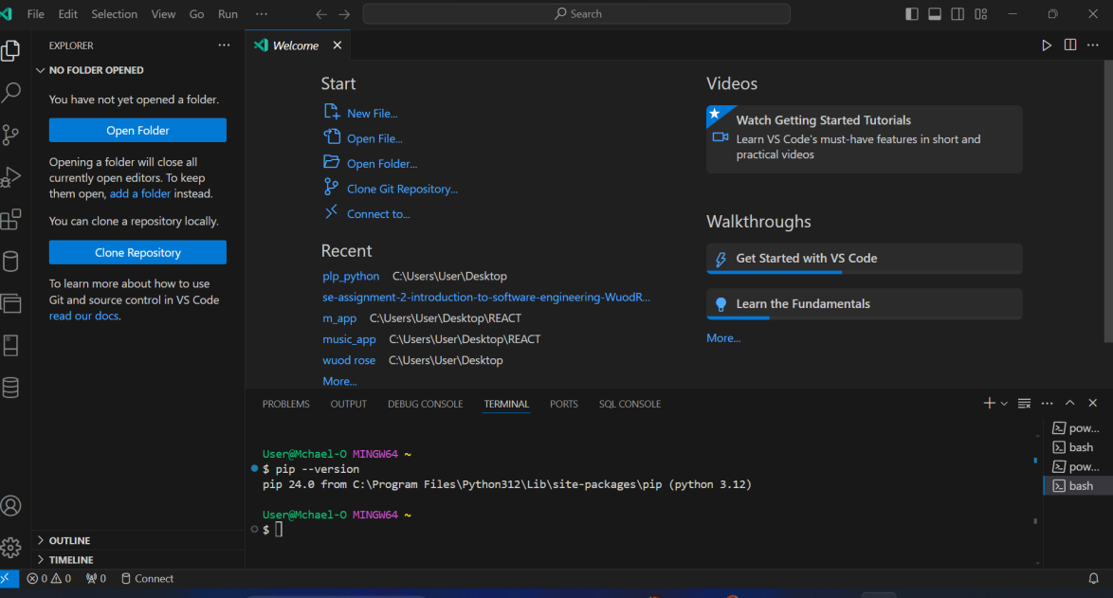

**6. Configure a Database (MySQL)**

Step 1: Visit [MySQL Download](https://dev.mysql.com/downloads/windows/installer/5.7.html" \t "_new).

* + - Download and install MySQL database.
    - Run the installer and follow the setup instructions.

Step 2: Set up your MySQL environment (user, password).

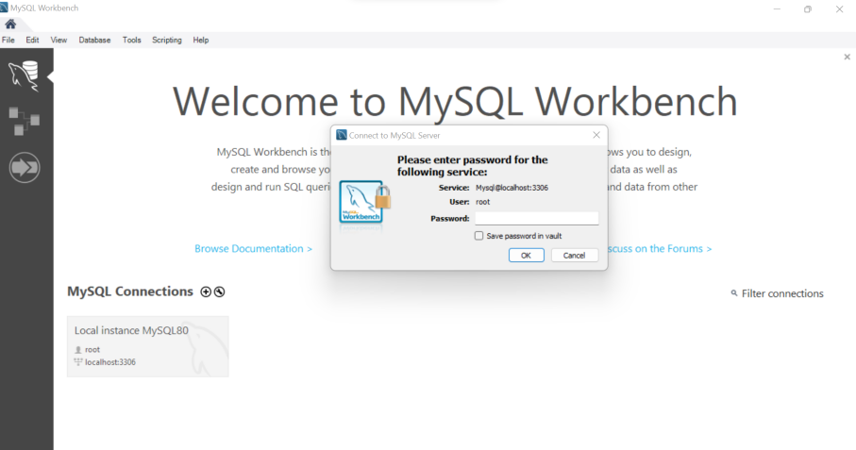

**7. Set up Development Environments and Virtualization (Optional)**

Step 1: Consider using virtualization tools like Docker or virtual machines to isolate project dependencies and ensure consistent environments across different machines.

* Visit Docker for Docker installation.

**8. Explore Extensions and Plugins**

Step 1: Explore available extensions, plugins, and add-ons for your chosen text editor or IDE to enhance functionality.

* + - * Open VS Code.
      * Go to the Extensions view (Ctrl+Shift+X).
      * Search and install extensions such as:
      * Python for Python support.
      * Prettier - Code formatter.